# Faculty Success Start-up Checklist

* **Login to Faculty Success** <https://goto.unm.edu/faculty-success> using your UNM NetID and password.

If you are unable to login, email [asmss@unm.edu](mailto:asmss@unm.edu) so that we can enable your account.

* Navigate to the **Activities** tab along the top  
  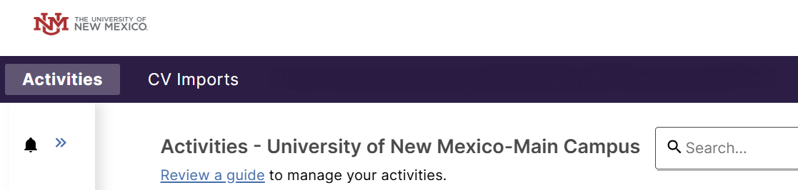

# Adding Your Data

* **Personal and Contact Information** (this is in the General Credentials/Expertise section).
  + OPTIONAL: Upload a copy of your CV if you would like it available on the Anderson website in the **Downloadable CV for Public Website** field. Note that this does NOT import your data from your CV into Faculty Success. This just makes a copy of your CV available as a downloadable file.
  + RERQUIRED: Upload a copy of your CV in the **CV for Internal Use Only** field. This copy is for your Chair and school leadership.
* **Biography and Expertise** (this is in the General Credentials/Expertise section). Some of this information will be published on the Anderson website.
* **Degrees** (this is in the General Credentials/Expertise section)
* **Licensures and Certifications** (this is in the General Credentials/Expertise section)
* **Publications** (this is in the Scholarship/Research section)
* **Presentations** (this is in the Scholarship/Research section)
* **University Service** (this is in the Service section)
* **Office Hours** (this is in the Teaching/Mentoring section)
* As time permits, you can go back and add **Awards and Honors**, **Media Appearances**, **Career Information** and other details that fully capture your body of work.